**Experiment 4**

**Aim:** To Study Full Wave Rectifier

**Tools Used:** Virtual Labs

**Theory:**

**Full Wave Rectifier**: A full-wave rectifier is exactly the same as the half-wave but allows unidirectional current through the load during the entire sinusoidal cycle (as opposed to only half the cycle in the half-wave). A full-wave rectifier converts the whole of the input waveform to one of constant polarity (positive or negative) at its output.

For a full wave rectifier,

**Average Output Voltage:**

$$V_{O}=V_{m}\sin{ωt} for 0≤ωt≤π$$

$$V_{av}=\frac{2V_{m}}{π}=0.636V_{m}$$

**RMS Load Voltage:**

$$V_{rms}=I_{rms}×R=\frac{V_{m}}{\sqrt{2}}$$

**Average Load Current:**

$$V_{av}=\frac{I_{av}}{R}=\frac{2I_{m}}{π×R}=\frac{2V_{m}}{π}$$

**RMS load current:**

$$I_{rms}=\frac{I_{m}}{\sqrt{2}}$$

**Form Factor:** It is defined as the ratio of rms load voltage and average load voltage.

$$F.F.=\frac{V_{rms}}{V_{av}}$$

$$F.F.=\frac{\frac{V_{m}}{\sqrt{2}}}{\frac{{2V}_{m}}{π}}=\frac{π}{2\sqrt{2}}=1.11$$

$$F.F.≥1$$

$$V_{rms}≥V_{av}$$

**Ripple Factor:**

$$γ=\sqrt{F.F.^{2}-1} ×100\%$$

$$γ=\sqrt{{1.11}^{2}-1}×100\%=48.1\%$$

**Efficiency:** It is defined as ratio of dc power available at the load to the input ac power.

$$η\%=\frac{P_{load}}{P_{in}}×100\%$$

$$η\%=\frac{I_{dc}^{2}×R}{I_{rms}^{2}×R}×100\%$$

$$η\%=\frac{\frac{{4I}_{m}^{2}}{π^{2}}}{\frac{I_{m }^{2}}{2}}×100\%=\frac{8}{π^{2}}×100\%=81.13\%$$

**Full Wave Rectifier – Waveforms:**

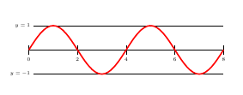

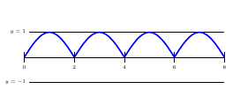

**Full wave Bridge Rectifier**: Bridge rectifier uses 4 rectifying diodes connected in a "bridged" configuration to produce the desired output but does not require a special centre tapped transformer, thereby reducing its size and cost. The single secondary winding is connected to one side of the diode bridge network and the load to the other side.

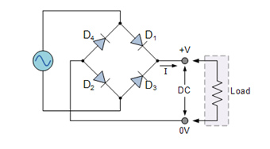

For Positive Half Cycle:

During the positive half cycle of the supply diodes D1 and D2 conduct in series while diodes D3 and D4 are reverse biased (ideally they can be replaced with open circuits) and the current flows through the load as shown below.

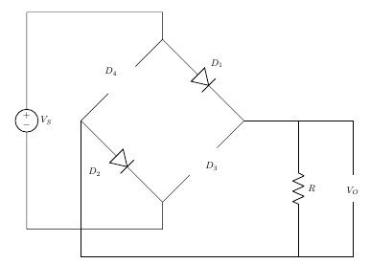

$$V_{o}-V_{I}=0$$

$$V_{o}=V_{I}$$

$$V_{O}=V_{I}-{2V}_{b}$$

$$V_{I}-2V_{b}-I×r_{d}=0$$

where,

VI is the input voltage,

Vb is barrier potential,

rd is diode resistance

For Negative Half Cycle:

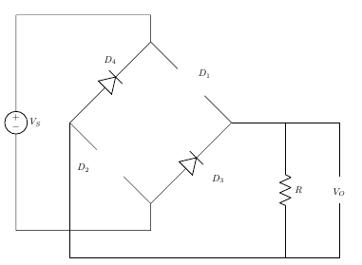

$$V_{o}-V_{I}=0$$

$$V_{o}=V_{I}$$

**Centre Tapped Full Wave Rectifier:**A Full-Wave Rectifier can be constructed using Centre-Tapped transformer – which give us two shifted sinusoids so that exactly one of the waveforms is positive at one time and two diodes. As compared to the half wave rectifier we use two diodes instead of one; one of the two diodes remain in conduction in both of the half cycles. At any point in time, only one of the diodes is forward biased. This allows for continuous conduction through load.

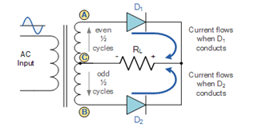

For Positive Half Cycle:

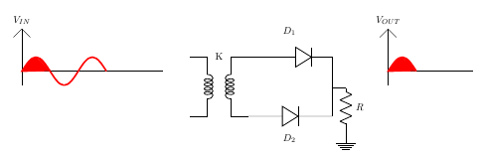

For Positive Cycle D1 is Forward Biased and D2 is Reverse Biased

$$V_{o}-V_{I}=0$$

$$V_{o}=V_{I}$$

For Negative Half Cycle:

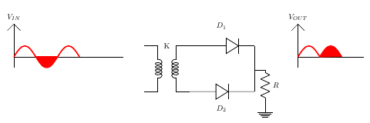

For Negative Cycle D1 is Reverse Biased and D2 is Forward Biased

$$V_{o}-V_{I}=0$$

$$V_{o}=V_{I}$$

**Peak Inverse Voltage:** For rectifier applications, peak inverse voltage (PIV) or peak reverse voltage (PRV) is the maximum value of reverse voltage which occurs at the peak of the input cycle when the diode is reverse-biased. The portion of the sinusoidal waveform which repeats or duplicates itself is known as the cycle. The part of the cycle above the horizontal axis is called the positive half-cycle, the part of the cycle below the horizontal axis is called the negative half cycle. With reference to the amplitude of the cycle, the peak inverse voltage is specified as the maximum negative value of the sine - wave within a cycle's negative half cycle.

For Bridge Rectifier,

D1 and D2 is Forward Biased

D3 and D4 is Reverse Biased

$$V_{o}-V_{m}=0$$

$$V_{o}=V_{m}$$

$$PIV=V$$

$$-V_{0 }+PIV=0⟹PIV=V_{m}$$

$$PIV≥V_{m}$$

For Center Tapped Rectifier,

D2 is Forward Biased,

PIV at D1,

$$V_{o}-V_{m}=0$$

$$V_{o}=V_{m}$$

$$PIV=V$$

$$-V_{0 }+PIV-V_{m}=0⟹PIV=2V_{m}$$

$$PIV≥2V_{m}$$

**Circuit Diagram:**

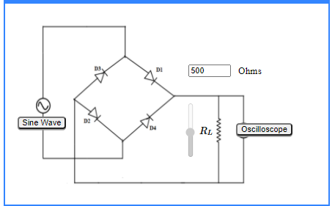

**Wiring Diagram:**

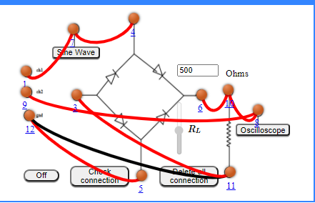

**Experimental Setup:**

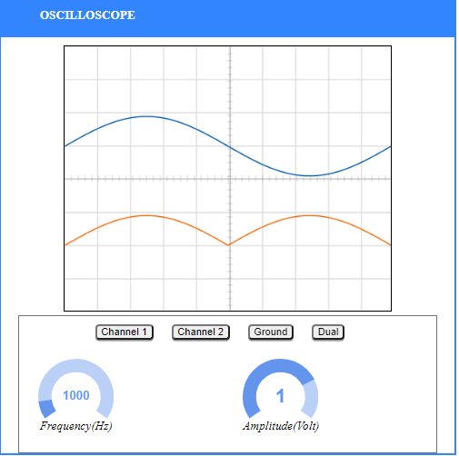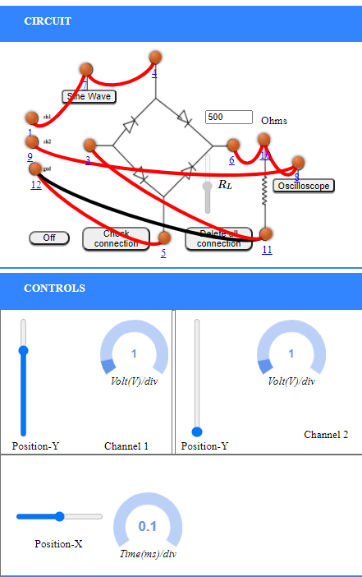

**Graph:**

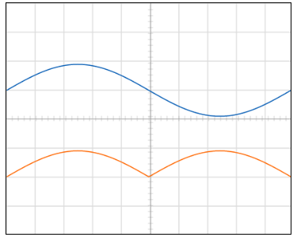

**Observations and Calculations:**

A.C. Frequency = 1000 Hz

Amplitude, Amp= 1Volts

$V_{m}$ = $Amp×\frac{volt}{div}=1×1=1Volts$

$V_{rms}=\frac{V_{m}}{\sqrt{2}}=\frac{1}{\sqrt{2}}=0.707V$ olts

$V_{dc}= \frac{{2V}_{m}}{π}$ = $\frac{2}{π}$ = 0.6369Volts

Ripple actor , $γ_{exp}$ = $\sqrt{{\left(\frac{V_{rms}}{Vdc}\right)}^{2}-1}$ = $\sqrt{1.11-1}$ = 0.33

Standard Value of Ripple Factor, $γ_{std}$ = 0.481

%Error = $\frac{γ_{exp}-γ_{std}}{γ_{std}}×100=31.39\%$

­

**Result:** The ripple factor of Full Wave Rectifier is = 0.33

Standard Value of ripple factor is = 0.481

Percentage error = 31.39%

**Conclusion:** The properties of full wave rectifier has been studied successfully and the ripple factor has been calculated successfully.